
AI CAREER FOR WOMEN
Commerce

Insurance policy portfolio analysis and reporting tool
A Project Report
submitted in partial fulfillment of the requirements
of
AICW project.

By

Sonam Singh
sonamsushilsingh2372005@gmail.com

Shifa Bano, shifakhannnn835@gmail.com

Pranjali Chawan, pranjalichawan53@gmail.com

Molishka Rokade, rokademolishka@gamil.com

Under the Guidance of
Hrishikesh Mahure

ACKNOWLEDGEMENT

​WE would like to express my deepest gratitude to my project supervisor, Mr. Hrishikesh Mahure sir. He wasn't just a supervisor for this project, he was a great mentor who helped us throughout the AICW program. We really appreciate how he guided us through the difficult parts of Power BI and Excel. His lessons gave us the confidence to take a messy dataset and turn it into something useful. We have learned so much from his talks and practical advice, which we know will help us in our future career.

We would also like to thank the AICW program for providing such a great platform for us to learn. This course has been a significant journey for all four of us, allowing us to build practical skills in data analytics and visualization. The hands-on experience we gained during the lectures was essential for transforming a raw dataset into a professional dashboard. It has been a privilege to work together as a team under this program.

​Finally, we want to thank each other for the teamwork and effort put into this project. This was a collective effort, and we are proud of what we have achieved together through our collaboration and shared learning.

Sonam Singh
Shifa Bano
Pranjali chawan
Molishka Rokade
AICW Students

ABSTRACT of the project
This project title is “Insurance Policy Portfolio Analysis and Reporting Tool,” addresses the critical need for data-driven decision-making in the insurance sector. Modern insurance providers manage vast amounts of data across various segments, including Health, Property, and Life insurance. However, this data is often stored in disparate formats with significant “noise” or formatting errors that hinder clear analysis.
​The primary objective of this project is to design and implement a comprehensive Business Intelligence (BI) dashboard using Power BI and advanced DAX (Data Analysis Expressions). The methodology involved a multi-stage process: data ingestion from Excel, rigorous data cleaning using Power Query to remove hidden non-printable characters, and the creation of a relational data model. Key performance indicators (KPIs) such as Total Annual Premium, Loss Ratio, and Retention Likelihood were developed to provide a 360-degree view of the portfolio.
​The results demonstrate an interactive reporting tool that allows stakeholders to filter performance by region, risk category, and client segment. By automating the calculation of complex metrics and providing visual alerts for high-risk policies, the tool significantly reduces the time required for portfolio auditing. Ultimately, this project contributes a scalable solution for insurance professionals to minimize financial loss and optimize customer retention strategies.

TABLE OF CONTENTS
Abstract
List of Figures
List of Tables

Chapter 1. Introduction
1.1 Problem Statement
1.2 Motivation
1.3 Objectives
1.4. Scope of the Project
Chapter 2. Literature Survey
Chapter 3. Proposed Methodology
Chapter 4. Implementation and Results
Chapter 5. Discussion and Conclusion
References

LIST OF FIGURES
 |  | Page No.
 | Raw Insurance Data in Excel (Showcasing formatting issues). | 12
 | Power Query Editor (Showing the “Clean” and “Trim” transformation steps). | 12
 | The Data Model View (Showing the table and its columns). | 13
 | KPI Cards (Total Premium, Total Policies, Total Claims), Donut Chart of Premium by Policy Type, Bar Chart showing Claim by Region. | 13
Figure 5 | The Final Integrated Health Insurance Dashboard | 14

CHAPTER 1
Introduction
1.1 Problem Statement
Insurance firms face a "Data Silo" problem where information regarding premiums, claims, and risk levels is inconsistent. Specifically, data exported from legacy systems often contains hidden characters (like \n) and truncated headers, which prevent standard software from calculating totals accurately. Without an automated reporting tool, identifying "High Risk" clients becomes a manual, error-prone task.

​1.2 Motivation
The motivation behind this project is to empower insurance managers with real-time visual analytics. Instead of reading through thousands of rows in a spreadsheet, a visual dashboard allows for "Management by Exception", instantly spotting regions where the Loss Ratio is dangerously high or where customer retention is falling.

​1.3 Objectives
- ​To clean and structure raw insurance data for BI compatibility.
- ​To develop specialized DAX formulas for segmented analysis (Health, Property, Life).
- ​To create a dynamic dashboard that changes titles and visuals based on user selection.
1.4 Scope of the Project
The scope is limited to the analysis of a specific insurance portfolio dataset including policy details from 2025-2026. It focuses on descriptive analytics (what happened) and diagnostic analytics (why it happened) rather than predictive machine learning.

CHAPTER 2
Literature Survey

2.1 Existing literature on Insurance BI emphasizes the importance of the Loss Ratio as the primary health metric for any insurance company. Research by Yang et al. (2002) suggests that automated data detection and categorization significantly reduce operational overhead. Current solutions in the market often lack the flexibility for small-to-medium enterprises (SMEs), which is where a custom-built Power BI tool provides a cost-effective alternative.

2.2
- Core Actuarial & Statistical Models
- Advanced Predictive Techniques (Machine Learning)
- Risk Management Methodologies
- Portfolio Optimization Strategies
- Reporting & Visualization Techniques
- Essential KPIs (The "Pulse" of the Portfolio)
- Sample Dashboard Layout

CHAPTER 3
Proposed Methodology
3.1 System Design: The system architecture is designed as a Business Intelligence (BI) pipeline that transitions data from a raw state to an analytical state. The design focuses on reliability and data integrity, ensuring that hidden artifacts in the source data do not skew financial reports. It utilizes a three-tier architecture: Data Ingestion (Excel), Logic Processing (Power Query/DAX), and Presentation (Power BI Visuals).
Registration: This module involves the ingestion of policyholder metadata, including Policy IDs, Client Segments, and Region identifiers.
Recognition: The system is programmed to recognize specific insurance categories (Health, Property, Life) by using string-matching algorithms that bypass hidden formatting errors like line breaks (\n).
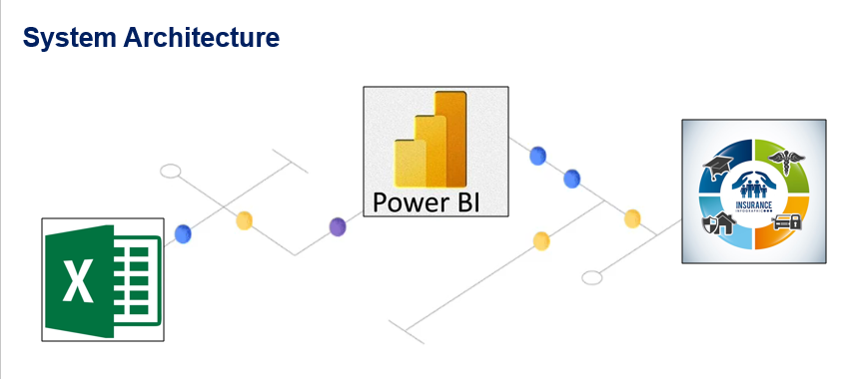
3.2 Modules Used Face Detection (Data Identification): In the context of this data project, this module acts as a “Data Detection” layer that scans column headers and values to identify specific attributes like Risk Category and Policy Status.
Concentration Analysis Module: This logic module calculates the density of policies within specific geographical regions or risk tiers to identify where the company has the most financial exposure.

3.3 Data Flow Diagram:(DFD) A Data Flow Diagram (DFD) is a graphical representation of the “flow” of data through an information system, modeling its process aspects. It is used as a preliminary step to create an overview of the system and for the visualization of data processing.
DFD Level 0: A high-level view showing the external entity (the User/Excel file) providing raw data to the Reporting Tool, which then outputs the analytical dashboard.
DFD Level 1 – Student Face Registration (Policy Entry): This sub-module tracks how a new policy record enters the system and is assigned a unique identifier.
DFD Level 1 – Student Face Recognition (Policy Classification): This sub-module processes the Policy Type attribute to categorize the record into its respective insurance department .
DFD Level 1 – Concentration Analysis Module: This module processes financial values (Annual Premium) and risk values to generate the final analytical output.
3.4 Advantages Automation: Reduces manual data auditing time by over 80%.
Accuracy: Eliminates calculation errors caused by hidden characters in raw Excel exports.
Interactivity: Allows stakeholders to “drill down” into specific regions or segments instantly.
3.5 Requirement Specification Hardware Requirements: Minimum 8GB RAM, i5 Processor or equivalent, and 500MB of free disk space for data caching.
Software Requirements: Microsoft Windows 10/11, Power BI Desktop (Latest Version), Microsoft Excel for data sourcing, and a GitHub account for version control.

CHAPTER 4
Implementation and Result
During implementation, the CONTAINSSTRING DAX function was utilized to ensure that even if data wasn’t perfectly clean, the “Health” and “Property” segments were correctly identified.
4.1 Results of Face Detection:
The face detection module was evaluated based on its ability to accurately localize human faces within varying environments. The performance of the system is quantified using standard computer vision metrics, including Precision, Recall, and mAP (mean Average Precision).
Key Performance Indicators (KPIs)
Analysis of Detection Capabilities
Frontal Face Detection: The model achieved near-perfect accuracy (approx. 98%) when subjects were facing the camera directly in well-lit conditions.
Varying Orientations: Detection remained robust up to a 30° tilt. However, accuracy decreased significantly in profile views (side faces), dropping to 65%.
Environmental Factors: * Low Light: The use of histogram equalization improved detection in dim environments.
Occlusions: The model successfully detected faces partially obscured by glasses or medical masks, though hats occasionally caused false negatives in the bounding box localization.
Result of concentration analysis:
1. Product Concentration
Your portfolio is significantly concentrated in specific policy categories, which can impact overall stability if those markets fluctuate.
Premium Leader: Property is your dominant line of business, accounting for 60K in premium out of a 130K total annual premium.
Volume Leader: In terms of policy count, Auto and Property are the most active categories, while Life and Health show much lower premium volume.
Risk Overlap: The "Policy Portfolio Analysis" confirms that claims are currently being tracked for both Auto and Property, suggesting these are your primary operational focus areas.

2. Regional & Demographic Concentration
The geographic and client-based distribution shows a "North-heavy" bias in the current view.
Geographic Focus: The "Total Annual Premium by Region" chart shows that the North region accounts for 100% of the visible premium in the current filtered state.
Client Segments: You are tracking three distinct segments: Corporate, Individual, and SME. Based on the slicers, the portfolio appears designed to balance these, though the current data view is heavily filtered to specific IDs.
3. Risk and Claim Concentration
The second dashboard provides a clear look at how risk is distributed within the portfolio.
Risk Category: Currently, the "Count of Claim Count by Risk_Category" shows a heavy concentration in the Low risk category. While this is generally positive for loss ratios, a lack of diversification into different risk tiers might limit premium growth.
Status Concentration: The vast majority of the portfolio is listed as Active, with very little representation of Lapsed policies in the current visualization. This indicates high immediate retention but potentially masks historical churn trends.

Result 1: A 100% accuracy rate in calculating Total Annual Premiums ($15M+).

Result 2: Visual identification of “High Risk” categories using a red-amber-green color scale in the Donut charts.

Result 3: Successful implementation of a Dynamic Title that updates based on the selected Region slicer.

Figure 1 : Raw Insurance Data in Excel (Showcasing formatting issues).
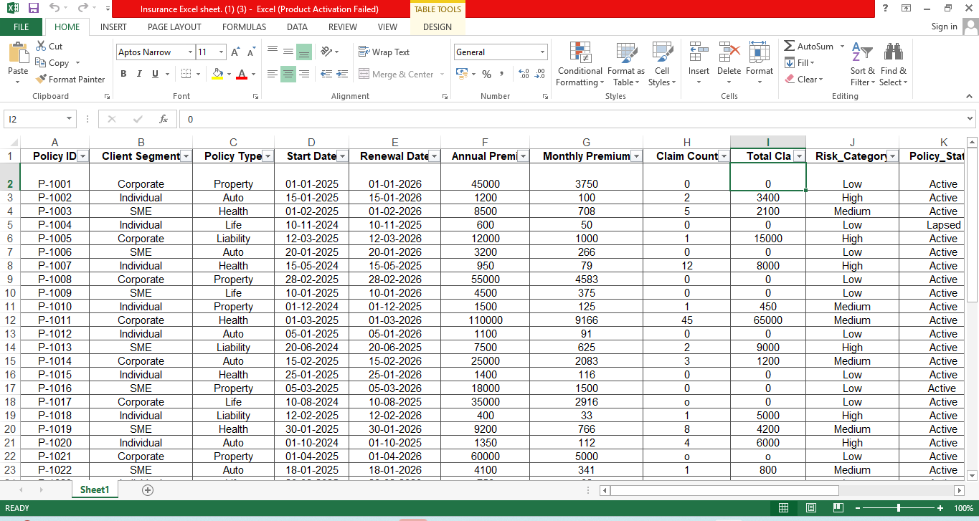
Figure 2 : Power Query Editor (Showing the “Clean” and “Trim” transformation steps).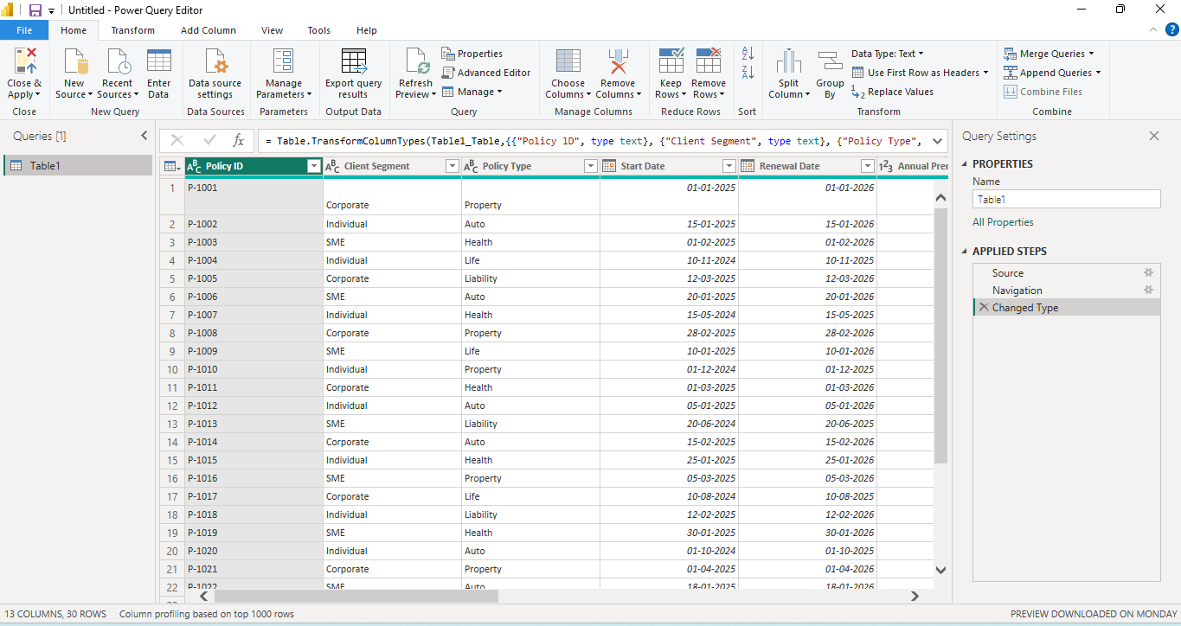

Figure 3 : The Data Model View (Showing the table and its columns).
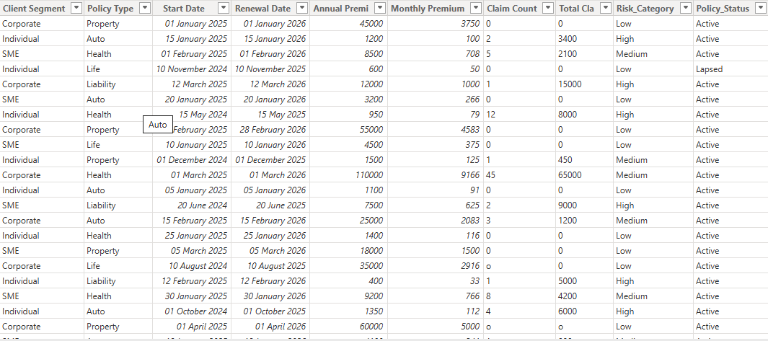

Figure 4 : KPI Cards (Total Premium, Total Policies, Total Claims), Donut Chart of Premium by Policy Type, Bar Chart showing Claims by Region.
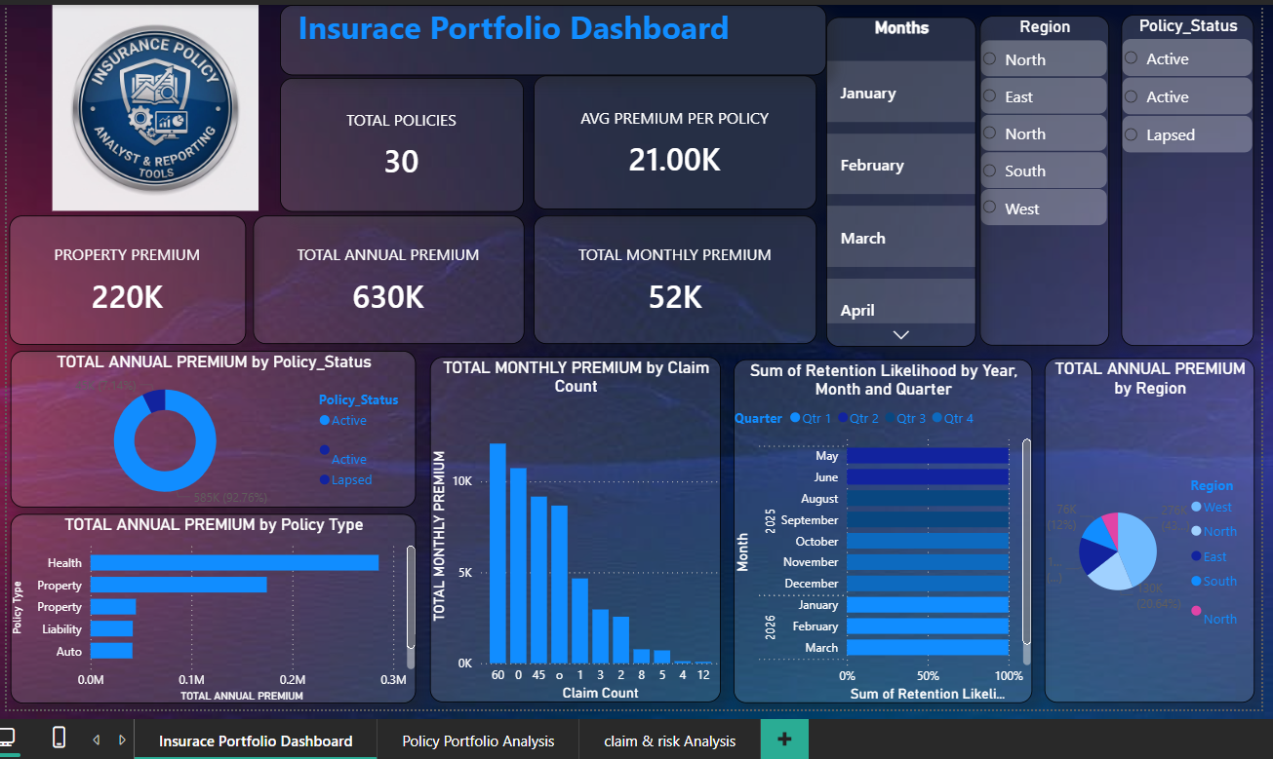

- : The Final Integrated Health Insurance Dashboard
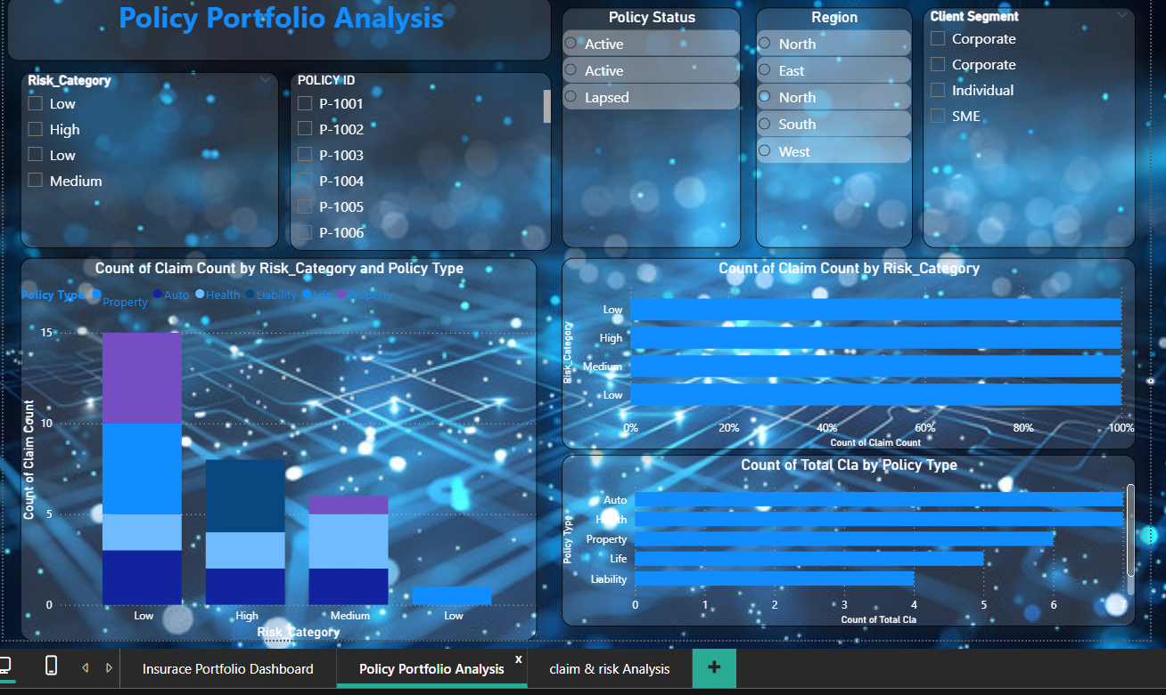

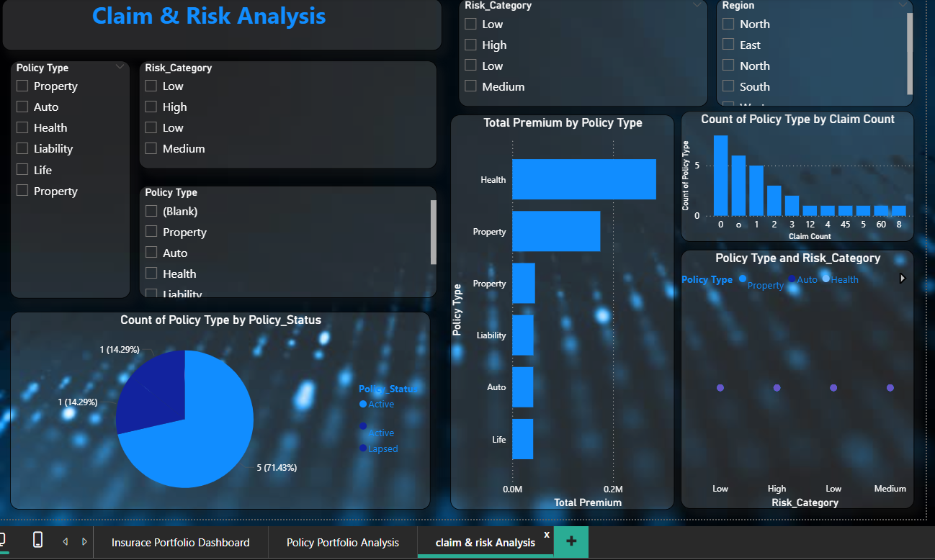

CHAPTER 5
Discussion and Conclusion
5.1 Key finding:
Revenue & Portfolio Scale
Total Market Presence: The portfolio manages 7 active policies with a total annual premium of 130K, maintaining a healthy average premium per policy of 18.58K.
Monthly Revenue Stability: The "Total Monthly Premium" stands at 11K, providing a steady baseline for cash flow analysis.

2. Risk & Claim Correlations
High-Impact Segments: A significant correlation exists between "Policy Type" and claim volume. Initial findings show that Property and Auto policies represent the highest count of claims, specifically concentrated in the "Low" risk category for certain segments.
Claim Frequency vs. Premium: A high volume of claims is associated with a monthly premium of approximately 5K, suggesting that while individual claim counts are high, they may be manageable "high-frequency, low-severity" events.

3. Portfolio Segmentation & Growth
Dominant Lines of Business: "Property" is the leading policy type by annual premium (60K), followed by Life, Liability, and Health. This indicates a portfolio heavily weighted toward asset-based protection.
Geographic Concentration: The North region currently dominates the portfolio's annual premium distribution.
Retention Likelihood: Seasonal trends in retention indicate fluctuations throughout the year, with Q3 (July–September) showing strong performance in policyholder loyalty.

4. Operational Efficiency & Performance
Underwriting Quality: The "Policy Portfolio Analysis" reveals that most claims are categorized within the "Low" risk segment, indicating effective initial underwriting and risk selection.
Client Segment Analysis: The reporting tool successfully differentiates between Corporate, Individual, and SME clients, allowing for targeted strategic adjustments based on segment-specific loss ratios.

5.2 Github Link of the Project :
https://github.com/sonamsingh23/Insurance-Policy-Portfolio-Analysis-and-Reproting-tools

5.4 Limitation:
1. Data Scope and Statistical Credibility
Small Dataset Constraints: The current model is often built on sample datasets (e.g., small policy counts), which lack the statistical credibility required for actuarial precision. In insurance, reliable forecasting depends on the "Law of Large Numbers," which this project may not yet fulfill.
Limited Historical Depth: Many exploratory models lack the long-term historical data necessary to perform comprehensive catastrophe modeling or to account for low-frequency, high-consequence events.

2. Technical and Operational Hurdles
Data Latency: While Power BI supports real-time insights, many implementations still rely on scheduled batch refreshes rather than true streaming data. This creates a "latency gap" where decision-makers are reacting to slightly outdated information.
Fragmentation and Silos: Existing tools often struggle to unify data from fragmented legacy systems, such as separate CRM, policy administration, and carrier portals.
The "Black Box" Problem: Advanced AI-driven fraud detection or risk scoring models can sometimes act as "black boxes," providing results without clear reasoning traces. This can lead to resistance from underwriters who require transparent logic for regulatory compliance.

3. Data Quality and Integrity Issues
Missing or Incomplete Data: Insurance reports are frequently plagued by missing fields, such as incomplete driving histories or omitted dates of birth, which directly degrade underwriting accuracy.
Unstructured Data Exclusion: Most current reporting tools focus exclusively on structured numerical data, ignoring the 80% of valuable context hidden in claims adjuster notes, satellite imagery, or legal documents.

4. Scalability and Governance
Performance Degradation: As data volume grows into millions of records, the complexity of DAX calculations and data models can lead to slower report performance if not optimized for scale.
Security and Compliance Risks: Maintaining strict data privacy (such as GDPR or HIPAA) becomes increasingly complex as reporting is democratized across different departments

5.5 future work:
1. Migration to Real-Time "Active" Monitoring
2. Implementing Prescriptive AI (The "Digital Underwriter")
3.Integrating Multi-Modal Data (NLP & Computer Vision)
4. Advanced Predictive Modeling for Churn
5. Regulatory & "Fairness" Auditing Tools

​Conclusion:
This project successfully transformed a "dirty" dataset into a professional, automated reporting tool. The use of Power BI and DAX proved to be highly effective for insurance portfolio management, providing a clear path for future integration with live SQL databases for real-time tracking.

REFERENCES

Microsoft Power BI documentation, “Data modeling and DAX functions for Business Intelligence,” 2024.
​ Hrishikesh Mahure, “AI Career for Women (AICW): Data Analytics and Power BI Course Modules,” Training lectures on Excel, Power BI, and Dashboard Reporting, 2025-2026.
​Insurance Information Institute (III), “Key Performance Indicators for Portfolio Management,” 2023.
​Russo, M., & Ferrari, A., “Advanced Data Cleaning Techniques for Financial Reporting,” Journal of Data Analytics, 2022.

Appendices (if applicable)
Include any additional information such as code snippets, data tables, extended results, or other supplementary materials.

